SPRINT-1

PYTHON IDE INSTALLATION

| **TEAM ID** | PNT2022TMID37769 |
| --- | --- |
| **PROJECT DOMAIN** | INTERNET OF THINGS |
| **PROJECT TITLE** | IoT BASED SMART CROP PROTECTION SYSTEM FOR  AGRICULTURE |
| **DATE** | 30 OCTOBER 2022 |

Python is a computer programming language often used to build websites and software, automate tasks, and conduct data analysis. Python is a general-purpose language, meaning it can be used to create a variety of different programs and isn't specialized for any specific problems.

# STEP 1:

* Python is installed successfully

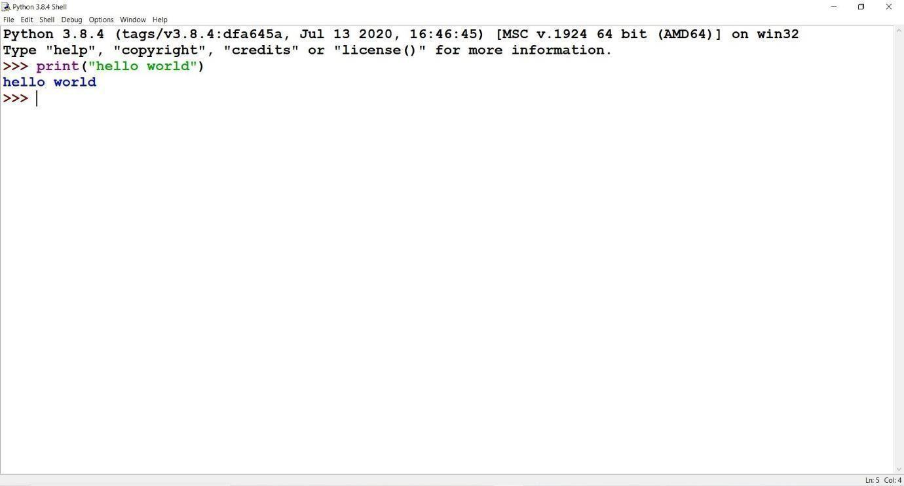

# STEP 2:

* The required python libraries are installed.
* Watson IoT Python SDK to connect to IBM Watson IoT Platform using python code is installed
* pip install wiotp-sdk

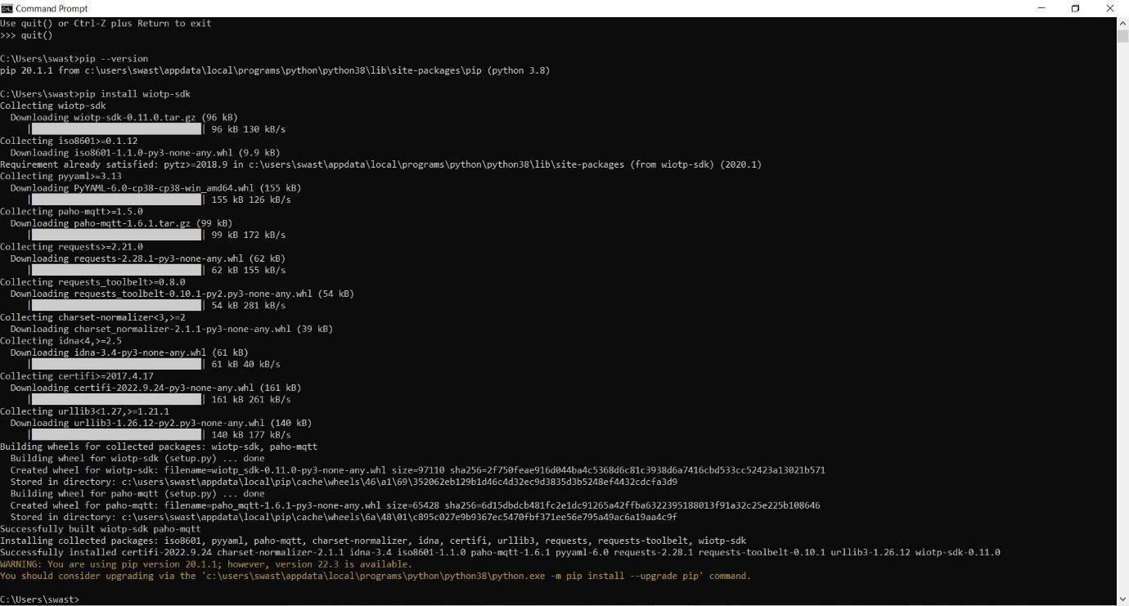

* Python client library for IBM Text to Speech is installed
* pip install --upgrade "ibm-watson>=5.0.0

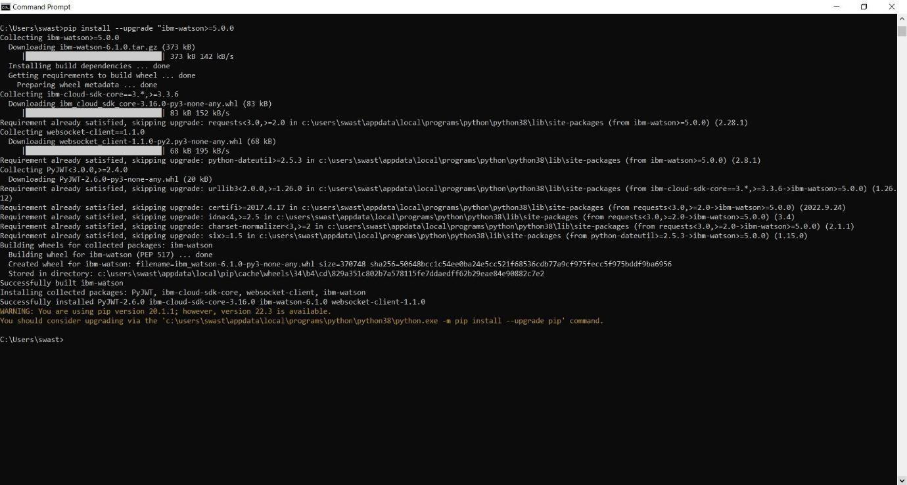

* Required libraries for Cloud object storage is installed.
* pip install ibm-cos-sdk

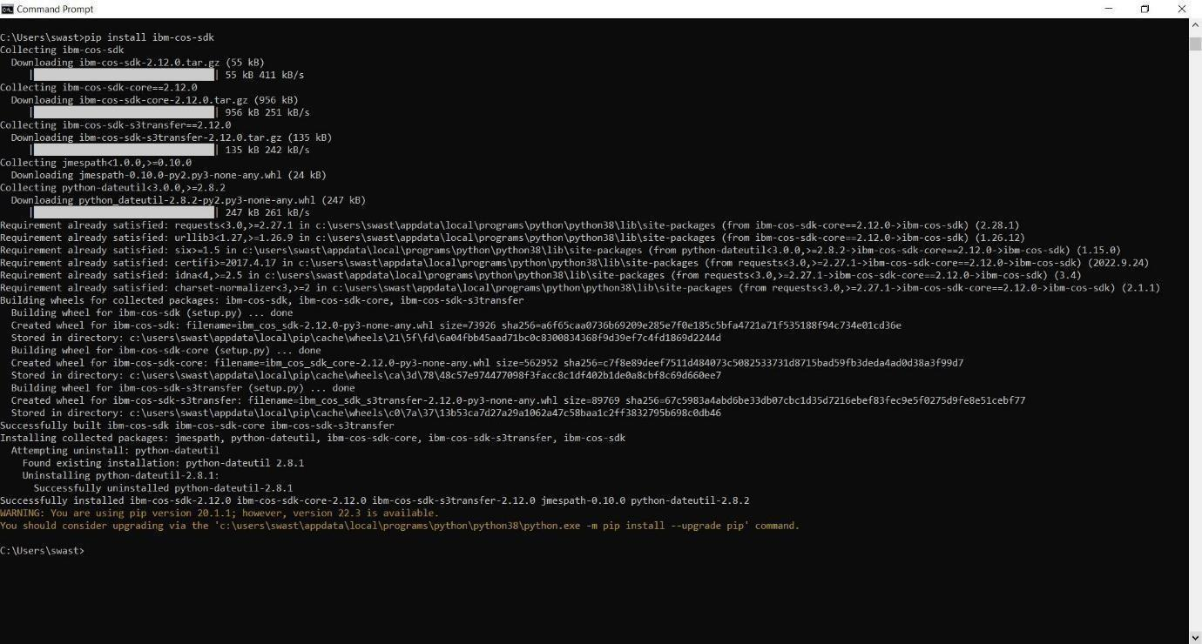

* pip install -U ibm-cos-sdk

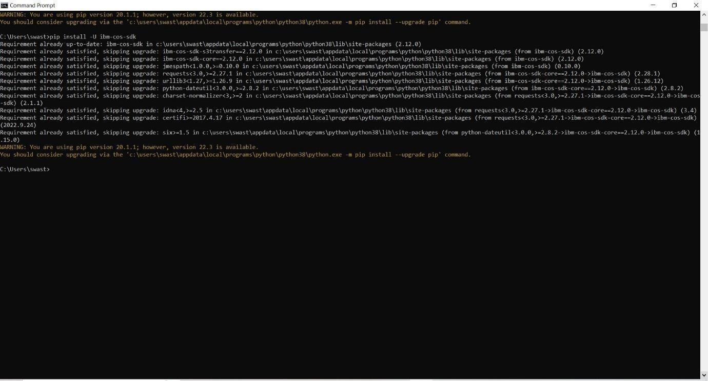

* pip install boto3

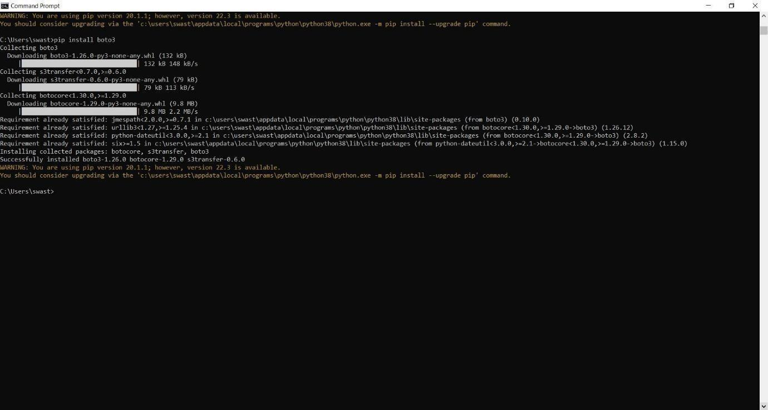

* pip install resources

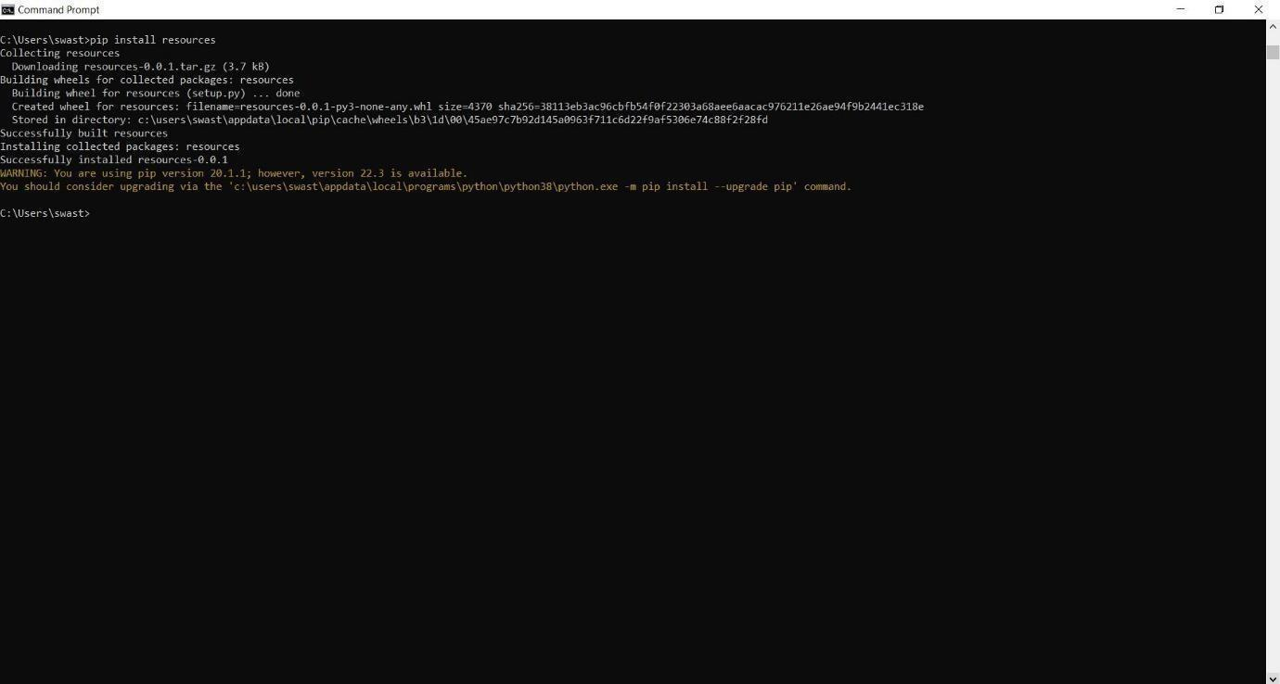

* pip install cloudant

